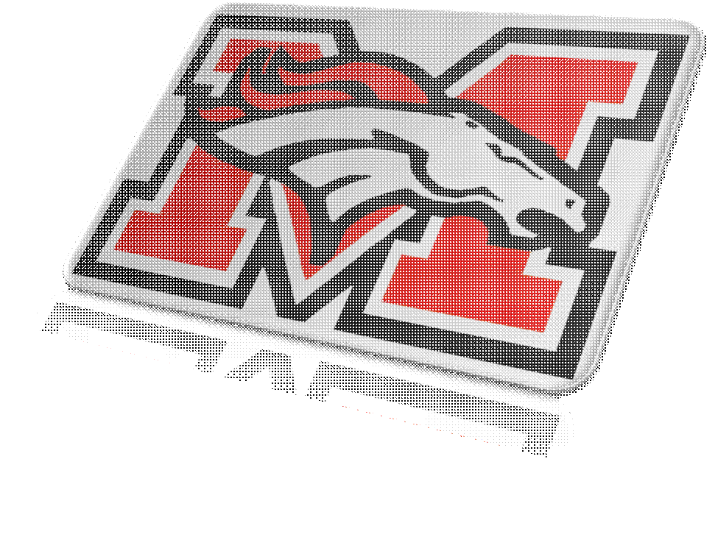
Class Rules and Guidelines
Mr. Guyer’s Tech Class

No Food or Drinks allowed in the computer room. No Exceptions
Respect your peers and teacher.
Abide by seating chart, there is one.
All students will remain seated in their chairs at their workstation.
No Cell Phones, IPods’, MP3 Players, CD Players, or any electronic devices in the room unless approved by teacher. I will not approve of any. Please do not ask.
No Pens or Paper or books allowed in the room. We will strive to be a paperless classroom. Some books will be handed to you, but they must stay in the room.
Respect all Mustang Public Schools property including but not limited to Computers, laptops, ipads, headphones, speakers, flip cameras, digital cameras, Monitors, muses, keyboards, CPU’s.
Talking will be limited. You are here to learn. Not to play or visit with friends during class. You will be very busy, we have lots to do. You will have a daily class itinerary that you must follow. The itineraries are kept in class so that you cannot lose them.
Please purchase or have a flash drive on you each day you come to class. The flash drive is the only device I allow in class and you need it to save your work on. We do not print paper. Remember we are a “Paperless Classroom”
All District rules apply in my classroom. They will not be broke.
I have read the following rules and guidelines for Mr. Guyer’s class and will respectfully follow them.

Print Name ___________________________________________
Date ______________________________
Class Period ________________

